**Project Planning Phase**

**Project Planning Template (Product Backlog, Sprint Planning, Stories, Story points)**

|  |  |
| --- | --- |
| Date | 16 JUNE 2025 |
| Team ID | LTVIP2025TMID33932 |
| Project Name | Revolutionizing Liver Care : Predicting Liver Cirrhosis using Advanced Machine Learning Techniques |
| Maximum Marks | 5 Marks |

**Product Backlog, Sprint Schedule, and Estimation (4 Marks)**

Use the below template to create product backlog and sprint schedule

| **Sprint** | **Functional Requirement (Epic)** | **User Story Number** | **User Story / Task** | **Story Points** | **Priority** | **Team**  **Members** |
| --- | --- | --- | --- | --- | --- | --- |
| Sprint-1 | Data Collection & Preprocessing | USN-1 | As a developer, I want to collect patient data from liver function test records and clinical databases. | 3 | High |  |
| Sprint-1 | Data Collection & Preprocessing | USN-2 | As a developer, I want to clean and preprocess the data by handling missing values and normalizing formats. | 5 | High |  |
| Sprint-2 | Model Development | USN-3 | As a data scientist, I want to build a machine learning model to predict the risk of liver cirrhosis. | 8 | High |  |
| Sprint-2 | Model Evaluation & Tuning | USN-4 | As a data scientist, I want to validate and tune the model using metrics like accuracy, precision, recall. | 4 | Medium |  |
| Sprint-3 | Real-Time Prediction & API Deployment | USN-5 | As a developer, I want to build APIs for real-time cirrhosis risk prediction based on new patient data. | 5 | High |  |
| Sprint-3 | Visualization & Results Interpretation | USN-6 | As a clinician, I want to view patient risk scores and contributing factors via a dashboard. | 6 | High |  |
| Sprint -4 | Visualization & Use Case Integration | USN-7 | As a developer, I want to integrate prediction APIs with a web interface for hospital use. | 3 | Medium |  |
| Sprint-4 | Patient Monitoring & Alert System | USN-8 | As a healthcare provider, I want to receive alerts for high-risk patients through SMS or email notifications. | 5 | High |  |

**Project Tracker, Velocity & Burndown Chart: (4 Marks)**

| **Sprint** | **Total Story Points** | **Duration** | **Sprint Start Date** | **Sprint End Date (Planned)** | **Story Points Completed (as on Planned End Date)** | **Sprint Release Date (Actual)** |
| --- | --- | --- | --- | --- | --- | --- |
| Sprint-1 | 8 | 5 Days | June 1, 2025 | June 5, 2025 | 7 | June 5, 2025 |
| Sprint-2 | 12 | 5 Days | June 8, 2025 | June 12, 2025 | 8 | June 12, 2025 |
| Sprint-3 | 11 | 5 Days | June15, 2025 | June 19, 2025 | 7 | June 19, 2025 |
| Sprint-4 | 8 | 5 Days | June 22, 2025 | June 26, 2025 | 6 | June 26, 2025 |

**Velocity:**

Imagine we have a 10-day sprint duration, and the velocity of the team is 20 (points per sprint). Let’s calculate the team’s average velocity (AV) per iteration unit (story points per day)

AV = sprint duration / velocity = 28/20 = 1.4

**Burndown Chart:**

A burn down chart is a graphical representation of work left to do versus time. It is often used in agile[software development](https://www.visual-paradigm.com/scrum/what-is-agile-software-development/) methodologies such as [Scrum](https://www.visual-paradigm.com/scrum/scrum-in-3-minutes/). However, burn down charts can be applied to any project containing measurable progress over time.

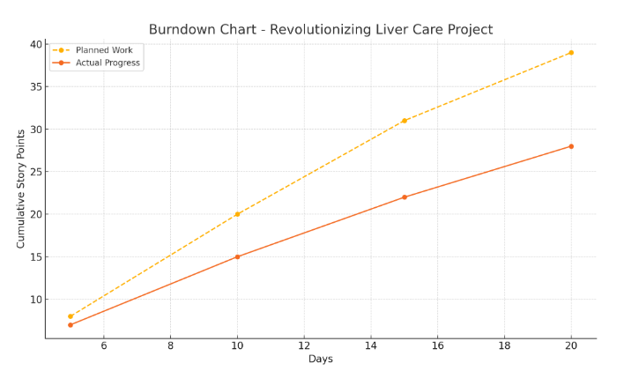

[**https://www.visual-paradigm.com/scrum/scrum-burndown-chart/**](https://www.visual-paradigm.com/scrum/scrum-burndown-chart/)

[**https://www.atlassian.com/agile/tutorials/burndown-charts**](https://www.atlassian.com/agile/tutorials/burndown-charts)

**Reference:**

[**https://www.atlassian.com/agile/project-management**](https://www.atlassian.com/agile/project-management)

[**https://www.atlassian.com/agile/tutorials/how-to-do-scrum-with-jira-software**](https://www.atlassian.com/agile/tutorials/how-to-do-scrum-with-jira-software)

[**https://www.atlassian.com/agile/tutorials/epics**](https://www.atlassian.com/agile/tutorials/epics)

[**https://www.atlassian.com/agile/tutorials/sprints**](https://www.atlassian.com/agile/tutorials/sprints)

[**https://www.atlassian.com/agile/project-management/estimation**](https://www.atlassian.com/agile/project-management/estimation)

[**https://www.atlassian.com/agile/tutorials/burndown-charts**](https://www.atlassian.com/agile/tutorials/burndown-charts)